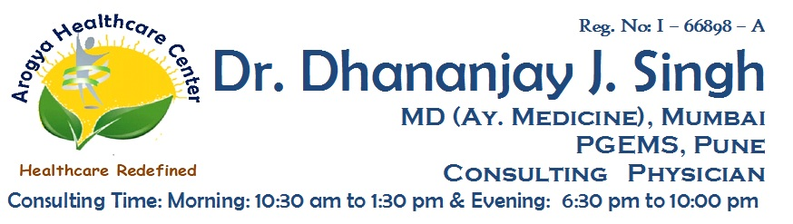

**Reg No: I-66898-A**

**Dr. Dhananjay J. Singh**

**MD (MEDICINE AY.) MUMBAI, PGEMS CONSULTING PHYSICIAN**

**Medical Certificate For Migration**

Date : / / 2020

This is to certify that

Mr./Mrs./Mast. /Miss...………………………………………………………………. Age: ………Years

Gender: Male / Female, ADHAAR No: ………………… …………………. ………………….

was examined by me at **Arogya Healthcare Center, Bhiwandi** and he/she is not showing

any symptoms of influenza like illness or that of COVID-19 like cough, fever or breathlessness

presently.

This screening is based on symptoms of patient and the certificate is issued to help him/her towards his /her migration on his/her/parent’s request. (COVID-19 test has not been done)

With their present medical condition, he/she can be considered fit to travel.

The incubation period of the communicable illness needs to be kept in mind in the view of COVID -19 situation and appropriate steps needs to be followed during and after transfer.

The COVID -19 guidelines shared by Government Of India must be followed.

**O/E**

SPO2 : …...%

T : …………F

P : ….…/min

**Dr. Dhananjay J. Singh**

(Signature with Stamp & Date)

.

**Address :** Shop No:3, Rosewood Building, Orchid Residency, Charnipada, Bhiwandi, Dist - Thane

**For Appointment** : +91 9967 134 911 | **In Case Of Emergency** : +91 9762 266 021